create database employeevck;

use employeevck;

create table dept(

deptno int,

dname varchar(20),

dloc varchar(20),

primary key(deptno));

create table employee(

empno int,

ename varchar(20),

mgr_no int,

hiredate date,

sal float,

deptno int,

primary key(empno),

foreign key(deptno) references dept(deptno)

on delete cascade on update cascade);

create table project(

pno int,

ploc varchar(20),

pname varchar(20),

primary key(pno));

create table incentives(

empno int,

incentive_date date,

incentive_amount float,

primary key(empno,incentive_date),

foreign key(empno) references employee(empno)

on delete cascade on update cascade);

create table assigned_to(

empno int,

pno int,

job_role varchar(20),

primary key(empno,pno),

foreign key(empno) references employee(empno)

on delete cascade on update cascade,

foreign key(pno) references project(pno)

on delete cascade on update cascade);

insert into dept values ('1','Cybersecurity','Hyderabad'),('2','Blockchain','Mysore'),('3','Cloud Computing','Bangalore'),('4','Web Development','Bangalore'),('5','Data Analytics','Mumbai');

select * from dept;

insert into employee values(101,'Ram',104,'2005-07-10',50000,3),(102,'Sam',104,'2008-03-27',55000,1),(103,'Hari',100,'2020-05-19',80000,2),(104,'Vishnu',108,'2016-08-23',75000,1),(105,'Vinod',101,'2009-12-07',70000,5);

insert into project values (21,'Bangalore','Webpage'),(22,'Mysuru','Google Cloud'),(23,'Mumbai','App dev'),(24,'Delhi','UI/UX'),(25,'Hyderabad','IOT');

insert into incentives values (101,'2005-11-03',10000),(102,'2009-12-07',20000),(103,'2021-05-06',25000),(104,'2018-07-06',20000);

insert into assigned_to values(101,22,'Fullstack dev'),(102,23,'UI/UX Designer'),(103,21,'Data Analyst'),(104,24,'Cybsec engineer'),(105,25,'Blockchain eng');

Query 1

Retreive empno of all employees who work for projects in Bangalorew,Mysuru and Hyderabad

Ans

select empno from project p,assigned_to a where p.pno=a.pno and p.ploc in('Bangalore','Hyderabad','Mysuru');

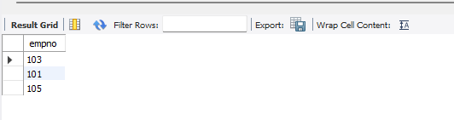

Query 2

Get employee id of those employees whop did not get incentives

select empno from employee e where e.empno not in (select empno from incentives);

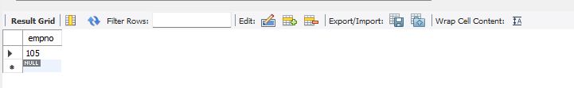

Query 3

Query to find emp name number,dept job role, dept location and project location for employees who are working for proj location same as dept location

select a.empno,a.pno,e.ename,e.deptno,d.dname,d.dloc,p.ploc from assigned_to a,project p,dept d,employee e where a.pno=p.pno and a.empno=e.empno and e.deptno=d.deptno and d.dloc=p.ploc;

